**Project Communication**

1. Definition and Importance
2. Cultural issues
3. Communication Requirements Analysis
4. Types of communication
5. Communication Plan

**Communication**

Throughout the project a need to communicate to

1. Project Sponsor
2. Team members
3. Other stakeholders
   1. Customers
   2. Clients
   3. Suppliers
   4. Partners
   5. The public

**For each group**

1. Purpose
2. Frequency
3. Format
4. Amount of time
5. Possible need for a hierarchy of reporting:
   1. Portfolio
   2. Program
   3. Project
   4. Task group

**Synchronous Options**

1. Face to face
2. Synchronous but not in the same place– (remember the time zones!)
   1. Conference call
   2. Video link
   3. Computer-assisted video conference
   4. IM; texting

**Asynchronous Options**

1. Courier, mail
2. E-mail
3. Fax
4. Project Blog
5. RSS
6. Social media presence

**Communication Planning**

1. Who?
2. Why?
3. What do they need/want to know? Or communicate to the project?
4. When? How frequently?
5. How? (what method(s) do they prefer? Are there methods that are unsuitable?
6. Who will be the contact point from the project for this communication?

**Team Meetings**

1. Purpose is to verify progress, identify challenges and get assistance where needed.
2. Frequency and duration may vary throughout the project
3. Be considerate and schedule “off-line” meetings if only a few are involved in a particular item. It wastes the time of the rest.
4. Frequent very short meetings may be more effective with a small team (daily “stand-up” meetings are a standard part of Agile Systems Development.)
5. PM may need to meet and report with other PMs in the same program or portfolio.

**Report to Management or Sponsor**

1. Frequency and format may be dictated by Sponsor
2. Purpose to report progress, identify challenges and changes, get support for necessary changes or added resources
3. Need balance between “raising the alarm” too early and waiting too long and being “in too deep”

**Other stakeholders**

1. The community may need to be consulted and informed—about the Riverview Lands project in Coquitlam.
2. Business customers or suppliers may be impacted by the project.
3. The project contractor/supplier needs to know about other aspects of the project and inform the PM of the status.
4. The government may have a role—permits, inspections, other
5. The Project Management Office
6. The frequency, format and content of communications may be dictated by law or 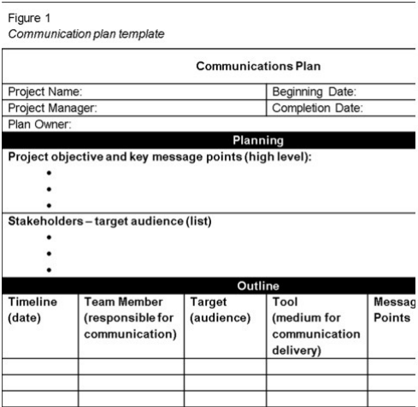may be a provision of a contractual agreement.

**Communication Plan Template**

**Summary**

1. Project Communication
2. Project communication is a key success factor
3. Start with a Communication Requirements Analysis and then Prepare a Communication Plan that considers all the stakeholders
4. Consider a variety of synchronous and asynchronous methods
5. Use appropriate technology
6. Consider cultural issues when planning and carrying out project communication
7. Remember communication is a two-way process, not always “broadcast!”